Practical No.1-A WAP to display three images using figure() function with title.
Code:
img1 = imread('D:\image processing pract\bandw.png');
img2 = imread('D:\image processing pract\cameraman.png');
img3 = imread('D:\image processing pract\color.png');
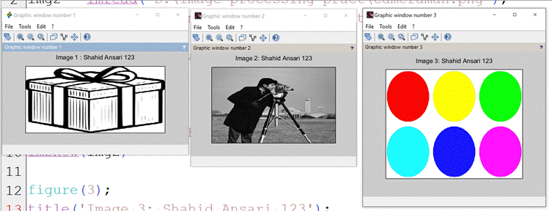
figure(1);
title('Image 1 : Alamin');
imshow(img1)
figure(2);
title('Image 2: Alamin');
imshow(img2)
figure(3);
title('Image 3: Alamin');
imshow(img3)

1B) WAP to display 3 images using the subplot() function with a title

img1 = imread('C:\Users\Alamin\Downloads\images (1).jpeg');
img2 = imread('C:\Users\Alamin\Downloads\pexels-pok-rie-33563-305086.jpg');
img3 = imread('C:\Users\Alamin\Downloads\images.jpeg');

subplot(2,2,1);
title('Image1:Alamin');
imshow(img1);
subplot(2,2,2);
title('Image2:Alamin');
imshow(img2);

subplot(2,2,3);
title('Image3:Alamin');
imshow(img3);

2A) Perform Image Enhancement in Spatial Domain a. Image Negative
f = imread("C:\Users\kc-cs\Downloads\Image processing\img.jpg");
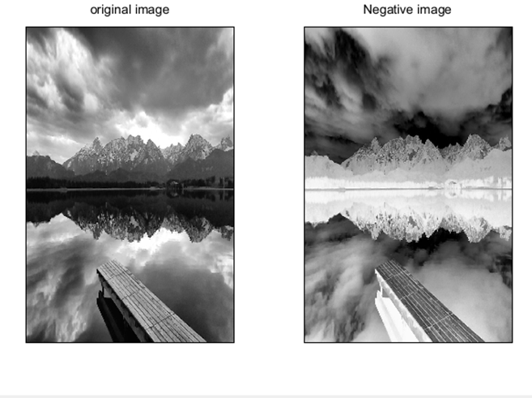
[rows,cols]=size(f);
g=zeros(rows,cols,"uint8");
for i = 1:rows
for j = 1:cols
r=f(i,j)
g(i,j)=255-r;
end
end
subplot(1,2,1);
imshow(f);
title("original image");
subplot(1,2,2);
imshow(g);
title("Negative image");

2B) Perform Image Enhancement in Spatial Domain b. Thresholding
f = imread("C:\Users\kc-cs\Downloads\Image processing\the.png");
[rows,cols]=size(f);
T=128;
g = zeros(rows,cols,"uint8");
for i = 1:rows
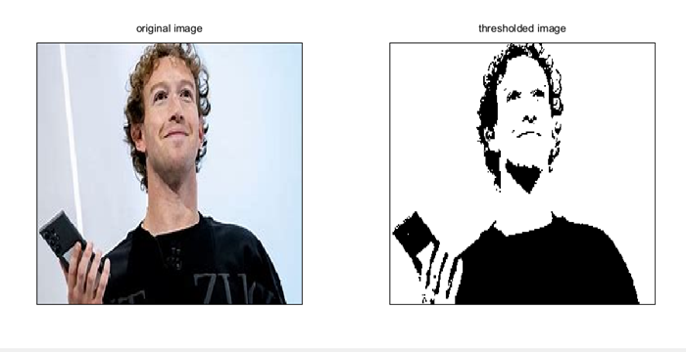
for j = 1:cols
r=f(i,j)
if r > T then
g(i,j)=255;
else
g(i,j)=0;
end
end
end
subplot(1,2,1);
imshow(f);
title("original image");
subplot(1,2,2);
imshow(g);
title("thresholded image");

3A) Image Enhancement in Spatial Domain a. Grey level slicing without background

f = imread("C:\Users\kc-cs\Downloads\Image processing\the.png");

[m,n]=size(f);
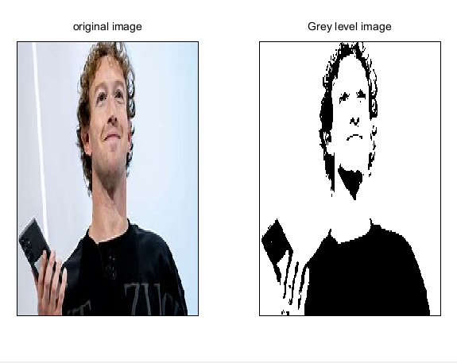
L =max(max (f));
a=round(L/2);
b=L;
for i=1:m
for j=1:n
r=f(i,j)
if(r>=a&b<=b)
g(i,j)=L;
else
g(i,j)=0;
end
end
end
g= uint8(g);
subplot(1,2,1);
imshow(f);
title("original image");
subplot(1,2,2);
imshow(g);
title("Grey level image");

3B) Image Enhancement in the Spatial Domain b. Contrast Stretching
clc
f=imread("C:\Users\kc-cs\Downloads\Image processing\the.png");
r1=100;
r2=140;
s1=150;
s2=240;
l=s1/r1;
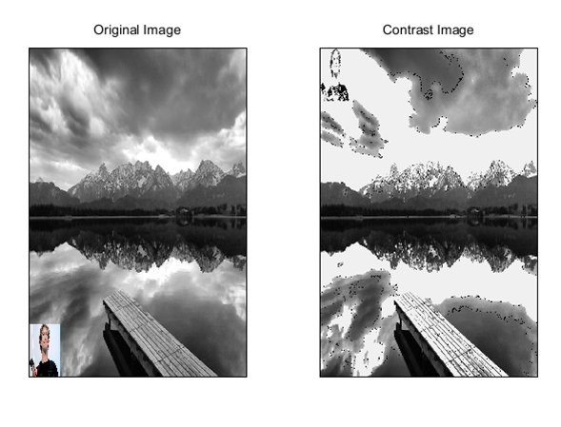
m=(s2-s1)/(r2-r1);
n=(255-s2)/(255-r2);
[rows cols] = size(f);
for i = 1:rows
for j = 1:cols
r = f(i,j)
if ((r > 0) && (r < r1))
g(i,j) = r*l;
end
if ((r > r1) && (r < r2))
g(i,j) = (m*(r-120))+s1;
end
if ((r > r2) && (r < 256))
g(i,j) = (n*(r-150))+s2;
end
end
end
subplot(1,2,1);
imshow(f);
title("Original Image"); subplot(1,2,2); imshow(g); title("Contrast Image");

Practical No.4-A : Basic transformation Log transformation
f = imread("C:\Users\Admin\Downloads\abc.jpg");
[m,n]=size(f);
for i=1:m
for j=1:n
r = f(i,j)
g(i,j)=100*log(1+double(r));
end
end
subplot(1,2,1);
imshow(f);
title("Original Image");
subplot(1,2,2);
imshow(g);
title("Log Tranform Image");
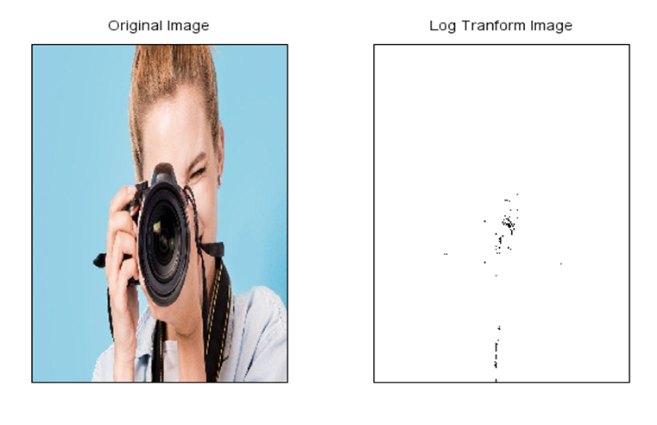

Practical No.4-B : POWER LAW TRANSFORMATION:
clear;
f = imread("D:\image processing\download.jfif");

[m,n]=size(f);

for i=1:m
for j=1:n
r = f(i,j)
g1(i,j)=20*(r^0.4);
g2(i,j)=20*(r^0.6);
g3(i,j)=20*(r^0.9);
end
end
subplot(1,4,1);
imshow(f);
title("Original Image");
subplot(1,4,2);
imshow(g1);
title("Exponential Tranform Image");
subplot(1,4,3);
imshow(g2);
title("Exponential Tranform Image");
subplot(1,4,4);
imshow(g3);
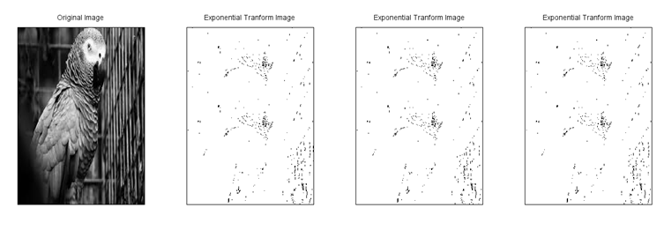
title("Exponential Tranform Image");

Practical No.5-A : Brightness enhancement of an image

clear;
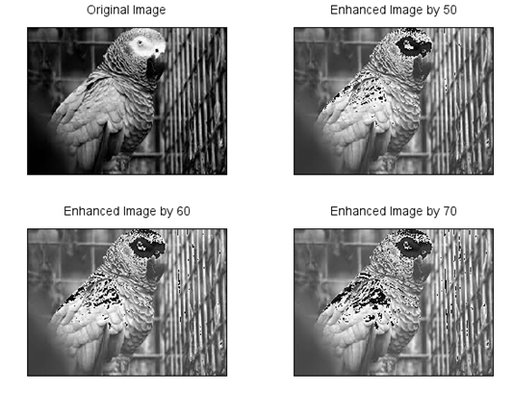
a = imread("D:\image processing\download.jfif");
b = a + 50
c = a + 60
d = a + 70
subplot(2,2,1)
imshow(a)
title('Original Image')
subplot(2,2,2)
imshow(b)
title('Enhanced Image by 50')
subplot(2,2,3)
imshow(c)
title('Enhanced Image by 60')
subplot(2,2,4)
imshow(d)
title('Enhanced Image by 70')

Practical No.5-B : b) Brightness suppression of an image
clear;
a = imread("D:\image processing\download.jfif");
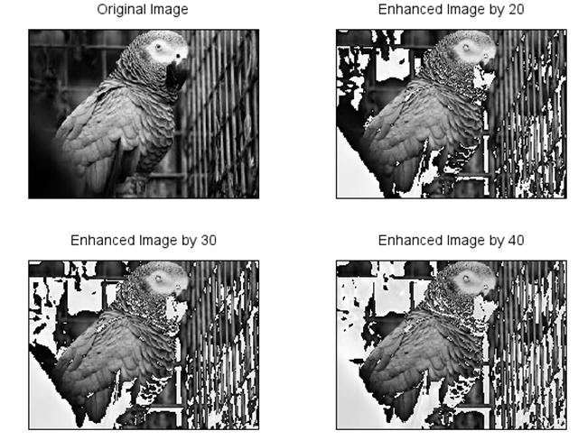
b = a - 20
c = a - 30
d = a - 40

subplot(2,2,1)
imshow(a)
title('Original Image')
subplot(2,2,2)
imshow(b)
title('Enhanced Image by 20')
subplot(2,2,3)
imshow(c)
title('Enhanced Image by 30')
subplot(2,2,4)
imshow(d)
title('Enhanced Image by 40')

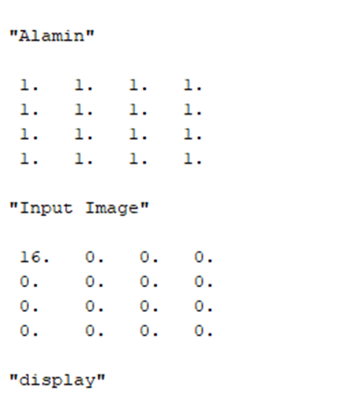
Practical No.6-A : DFT of 4x4 Gray scale image
f=[1 1 1 1; 1 1 1 1;1 1 1 1;1 1 1 1];
t=fft2(f);
disp('Alamin')
disp(f,'Input Image')
disp(t,'display')
or
f=[1 1 0 1;1 0 1 1;1 0 1 1;1 1 0 1];
F=fft2(f);
disp('DFT Exampl - Alamin')
disp(f,'Input Image')
disp(t,'display')
subplot(221);
imshow(f);
title('Image in spatial domain')
subplot(223);
imshow(F);
title('Image in frequency domain')

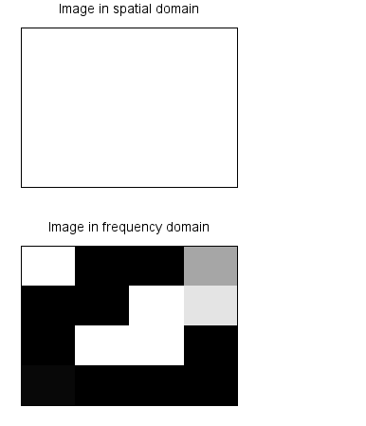
Practical No.6-B: Compute the discrete cosine transform
f=[2 4 4 2;4 6 8 3;2 8 10 4;3 8 6 2];
F=dct(f);
disp(F,'Discrete Cosine Transform of f(m,n) using dct function');
subplot(221);
imshow(f);
title('Image in spatial domain')
subplot(223);
imshow(F);
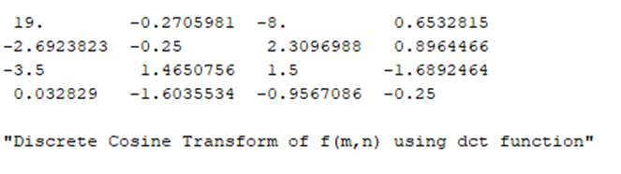
title('Image in frequency domain')

Practical No.7-A: Write a program to plot a Histogram for Colour and Grayscale Images.
img=imread("C:\Users\Admin\Downloads\TOTA.jpg");
subplot(131)
imshow(img);//24 Bits
title("Original Color Image");
mg_gray=rgb2gray(img);
subplot(132)
imshow(mg_gray);//8 Bits
title('GrayScale Image');
//Compute Histogram
nbins=256;
[h,x]=imhist(mg_gray,nbins);
//Display Histogram
subplot(133);
bar(x,h);
title('Histogram Image [Alamin 01]');
xlabel('Intensity Values');
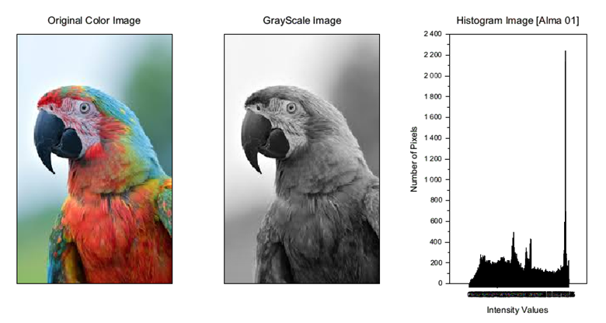
ylabel('Number of Pixels');

Practical No.7-B : Implementation of Run Length Encoding compression method
data = [1 1 1 2 2.3 3 3 3 4 4 4 5 5 5 6];
values = [];
counts = [];
count = 1;
n = length(data);
for i = 2:n
if data (i) == data (i-1) then
count = count + 1;
else
values($+1)= data (i-1);
counts($+1)= count;
count = 1;
end
end
values ($+1) = data($);
counts($+1) = count;
disp("Original Data : Alamin");
disp(data);

disp("Run length Encoding Data (values, Count):");
for i = 1: length (values)
mprintf("(%d, %d)\", values(i), counts(i));
end
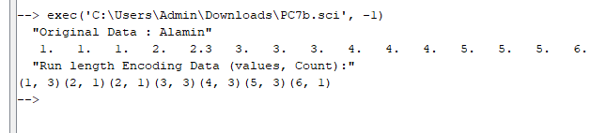

Practical No.8-A : WAP to study the effects of reducing the quantization values and spatial resolution.
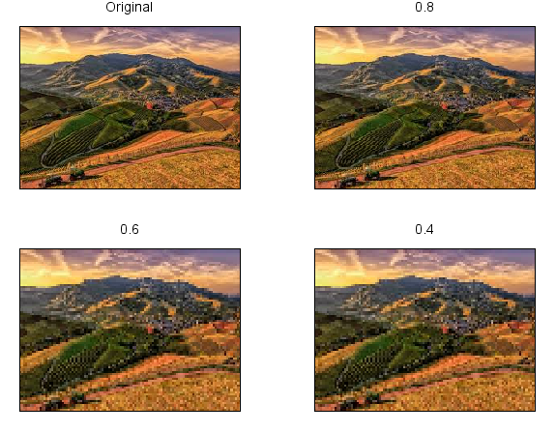
img= imread("D:\Image Processing\download (1).jpg");
[m,n]=size(img)
for i=1:m
for j=1:n
b(i,j)=(img(i,j))/256*63;
c(i,j)=(img(i,j))/256*127;
d(i,j)=(img(i,j))/256*191;
end
end
subplot(2,2,1),imshow(img),title('Original');
subplot(2,2,2),imshow(b),title('Quantized 63');
subplot(2,2,3),imshow(c),title('Quantized 127');
subplot(2,2,4),imshow(d),title('Quantized 191');


8b). Spatial Resolution Image
i= imread("D:\Image Processing\download (1).jpg");
a=imresize(i,0.8);
b=imresize(i,0.6);
c=imresize(i,0.4);
subplot(2,2,1),imshow(i),title('Original');
subplot(2,2,2),imshow(a),title('0.8');
subplot(2,2,3),imshow(c),title('0.6');
subplot(2,2,4),imshow(c),title('0.4');

Practical No.9-A : Write a program to apply following morphological operations on the image.
9a) Opening img
i= imread("D:\Image Processing\download (1).jpg");
se1=testmatrix('square',11);
im2=imerode(i,se1);
im3=imerode(im2,se1);
subplot(1,2,1),imshow(i),title('Original');
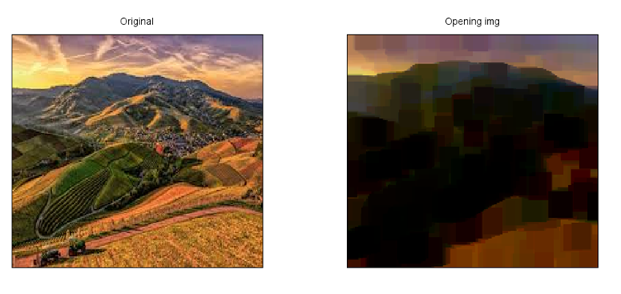
subplot(1,2,2),imshow(im3),title('Opening img');\

9b) Closing img
i= imread("D:\Image Processing\download (1).jpg");
se1=testmatrix('square',11);
im2=imdilate(i,se1);
im3=imerode(im2,se1);
subplot(1,2,1),imshow(i),title('Original');
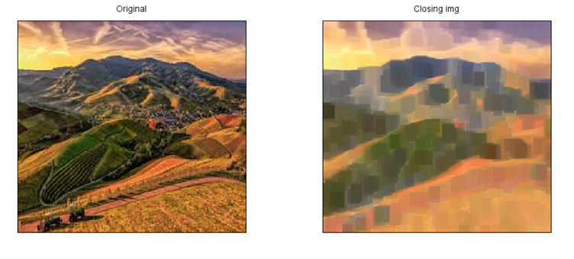
subplot(1,2,2),imshow(im3),title('Closing img');

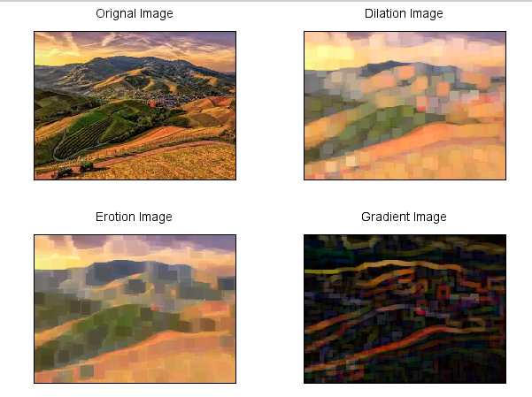
C. Morphological Gradient
img= imread("D:\Image Processing\download (1).jpg");
se1=testmatrix('square',12);
im1=imdilate(img,se1);
im2=imerode(im1,se1);
g=im1-im2;
subplot(2,2,1),imshow(img),title('Orignal Image');
subplot(2,2,2),imshow(im1),title('Dilation Image');
subplot(2,2,3),imshow(im2),title('Erotion Image');
subplot(2,2,4),imshow(g),title('Gradient Image');

D. Top-hat transformation
i= imread("D:\Image Processing\download (1).jpg");
se1=testmatrix('square',22);
im1=imerode(i,se1);
im2=imdilate(im2,se1);
h=i-im2;
subplot(2,2,1),imshow(i),title('Orignal Image');
subplot(2,2,2),imshow(im1),title('Erotion Image');
subplot(2,2,3),imshow(im2),title('Dilation Image');
subplot(2,2,4),imshow(h),title('Top Hat Transformation Image');
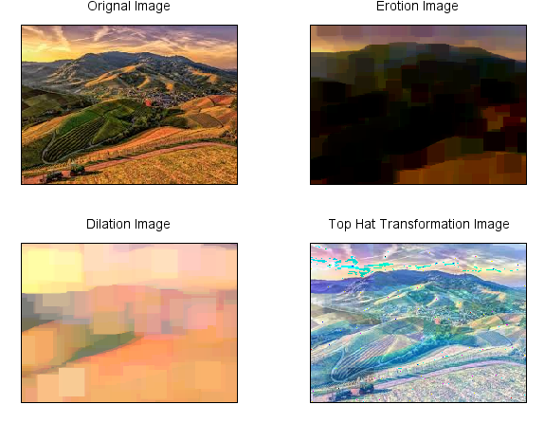

Practical No.10-A : Write a program for boundary detection.
clear;
clc;
aa=imread("D:\Image Processing\images.jpg");
se1=testmatrix('square',11);
m1=imerode(aa,se1);
m2=aa-m1;
subplot(2,1,1),imshow(aa);
title('orignal image');
subplot(2,1,2),imshow(m2);
title('edge detection');

